**SMILE FARM**

**Project Report**

**Version 1.0**

**Industrial Training & Presentation (ECS791)**

**BACHELOR OF TECHNOLOGY (CSE)**

|  |  |
| --- | --- |
| PROJECT GUIDES:  Internal Guides:  **Mr.Mahendra Singh Sagar**  **Ms.Deepti Aggarwal**  External Guide:  **Mr. Amit Kumar Roy** | SUBMITTED BY:  **Paras Rastogi (TCA1409048)**  **Swapnil Jain (TCA1409072)** |

November,2017



**COLLEGE OF COMPUTING SCIENCES AND INFORMATION TECHNOLOGY**

**TEERTHANKER MAHAVEER UNIVERSITY, MORADABAD**

**ACKNOWLEDGEMENT**

We take this opportunity to offer our significant thanks and profound respects to our guide Mr. Amit Kumar Roy for his excellent direction, monitoring and support over the span of this whole project. The blessing, help and direction given by him shall take us far in the voyage of life on which we are going to set out.

We also take this opportunity to express a profound feeling of appreciation to Mr. Mahendra Singh Sagar and Ms. Deepti Aggarwal, Asst. Professor, TMU, for their sincere help, important data and direction, which helped us in finishing this assignment through different stages.

We are also obliged to staff individuals from TMU, for the important data given by them in their separate fields and are thankful for their participation amid the time of our task.

Finally, we thank the almighty, our folks, sibling, sisters and companions for their steady consolation without which this task would not have been conceivable.

Paras Rastogi (TCA1409048)

Swapnil Jain (TCA1409072)

**Place: Moradabad**

**Date: 22/11/17**

**DECLARATION**

We hereby declare that this Project Report titled SMILE FARM submitted by us and approved by our project guide, to the College of Computing Sciences and Information Technology (CCSIT), Teerthanker Mahaveer University, Moradabad, is a bonafide work undertaken by us and it is not submitted to any other University or Institution for the award of any degree diploma / certificate or published any time before.

|  |  |  |
| --- | --- | --- |
| **Project Group :** | Smile Farm Developers | |
| **Student Name:** | Paras Rastogi | Signature |
|  |  |  |
| **Student Name:** | Swapnil Jain | Signature |
|  |  |  |
|  |  |  |
| **Project Guide: (External)** | Mr. Amit Kumar Roy | Signature |
|  |  |  |
| **Project Guide: (Internal)** | Mr.Mahendra Singh Sagar | Signature |
|  |  |  |
|  |  |  |
| **Project Guide: (Internal)** | Ms.Deepti Aggarwal | Signature |
|  |  |  |

**Brief About the Company**

IBM (International Business Machines Corporation) is an American multinational technology organization situated in Armonk, New York, United States, with operations in over one hundred and seventy international places. The enterprise originated in 1911 due to the fact the Computing-Tabulating-Recording Company (CTR) and became renamed "International Business Machines" in 1924.

IBM produces and markets pc frameworks equipment, middleware and programming program, and offers net web facilitating and counseling offerings in regions running from centralized server PCs to nanotechnology. IBM is additionally a central research organization, keeping the report for most extreme licenses produced with the guide of way of a business (starting at 2017) for twenty-four continuous years. Developments with the asset of IBM incorporate the programmed teller machine (ATM), the PC, the floppy plate, the troublesome circle strain, the attractive stripe card, the social database, the SQL programming dialect, the UPC standardized tag, and dynamic irregular get right of access to memory (DRAM).

IBM has a gigantic and various arrangement of administrations and items. Starting at 2016, the ones offerings fall into the sorts of distributed computing, intellectual registering, trade, records and investigation, Internet of Things, IT framework, portable, and wellbeing.

IBM Cloud incorporates framework as a supplier (IaaS), programming program application as an organization (SaaS) and stage as a supplier (PaaS) provided through open, non-open and half and half cloud conveyance styles. For instance, the IBM BluemixPaaS licenses manufacturers to fast make complex sites on a compensation as-you-cross model.

IBM SoftLayer is a devoted server, oversaw web site facilitating and distributed computing organization, which in 2011 forewarned web facilitating more than 81,000 servers for included than 26,000 clients. IBM additionally offers Cloud Data Encryption Services (ICDES), the utilization of cryptographic part to comfortable purchaser records.

Table of Contents

1 Smile Farm 6

2 Smile Farm Problem Statement 6

3 Smile Farm Description 6

3.1 Scope of the Work 6

3.2 Smile Farm Modules 7

3.3 Context Diagram (High Level) 7

4 Implementation Methodology 8

5 Technologies to be used 9

5.1 Software Platform 9

5.2 Hardware Platform 10

5.3 Tools: 10

6 Advantages of this Project 10

7 Assumptions 10

8 Future Scope and further enhancement of the Smile Farm 11

9 SMILE FARM Repository Location 11

10 Definitions, Acronyms, and Abbreviations 11

11 Conclusion 11

12 References 12

**Appendix**

**A:Data Flow Diagram (DFD)**

**B:Entity Relationship Diagram (ERD)**

**C:Use Case Diagram (UCD)**

**D:Data Dictionary (DD)**

**E: Screen Shots**

# Smile Farm

“Smile Farm- an e-Revolution for Farmers”

The primary goal of the venture is to take the most recent data and information contributions to the ranchers with the goal that they can enhance their profitability and financial prosperity by enlisting and tending to their issues on the composed gateway for successful correspondence and arrangements.

# Smile Farm Problem Statement

The Indian farmers are dependent on timely supply of the fertilizers for maintaining their soil productivity. Majority of the Indian farmers are very poor and illiterate which results in improper application of fertilizers. They lack in awareness and education and often depend on unscrupulous middlemen for advice.

The objective is to take the most recent data and information contributions to agriculturists with the goal that they can enhance their efficiency and enhance their monetary prosperity.

# Smile Farm Description

The thought process of this report is to characterize degree and necessities of a rural activity "Grin Farm". It is a dream of stretching out e-unrest to agriculturists and cooperatives through a 3-pronged technique:

a) Development of know-how data sources and e-administrations of pertinence to rustic India,

b) Evolve intense scattering systems to move fiery utilization of the offices through ranchers and cooperatives,

c) The expansive aim is to enable agriculturists and cooperatives through present day in information and correspondence time.

## Scope of the Work

“Smile-Farm” will provide a secure user-id/password based login mechanism to access its services. Once logged in to the community, the user (Administrator/Content Manager/Subject Matter Expert, SME/Farmer) can use the services to fulfill their requirements. Login will be a prerequisite to use Smile-Farm. Internal users will be provided user id/password pair separately.

Once user logs in, s/he can view the dashboard of farmer queries with status, Latest Tips and Advisories added by SMEs are displayed.

## Smile Farm Modules

Smile Farm is an independent cloud community and it will have a navigation menu on the top consisting of tabs (modules) as per the access privileges specified to each user by the administrator.

* **Chatter:** this is the default landing page of each user when logged into the Smile Farm community. This module enables the user for interacting with each other effectively.
* **Dashboards:** this module is made available to both the administrator as well as the content manager. Dashboard module consists of the “Smile Farm Tracking System” to keep track of all the records present in the Smile Farm.
* **Master Modules:** this module is made available to both the administrator as well as the content manager. Master modules include specific modules such as State Master, Location Master, Category Master and SME master for data entry.
* **Category Modules:** this module is made available to both the administrator as well as the content manager. Category Modules include specific module such as SME category for the data entry.
* **Reports:**  this module is visible to both the content manager as well as the administrator for creating and analyzing the prepared reports.
* **Query Module:** this module is only visible to the farmer for addressing their issues and posting their queries. All their queries are resolved by the SME via Resolved Queries/Pending Queries module.
* **Farmer Details Module:** this module is solely made available to the farmers and the SME for registering and responding to farmer’s queries respectively.

## Context Diagram (High Level)

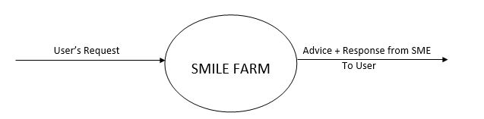

Fig. 1: 0 – Level DFD

# Implementation Methodology

All the modules of the “Smile-Farm” have been designed together to serve the purpose of interactiveness and ease of access to its different users by the help of Salesforce CRM.

The high level functional necessities for the Smile-Farm are sketched out in the Use Case graph portrayed in this area.

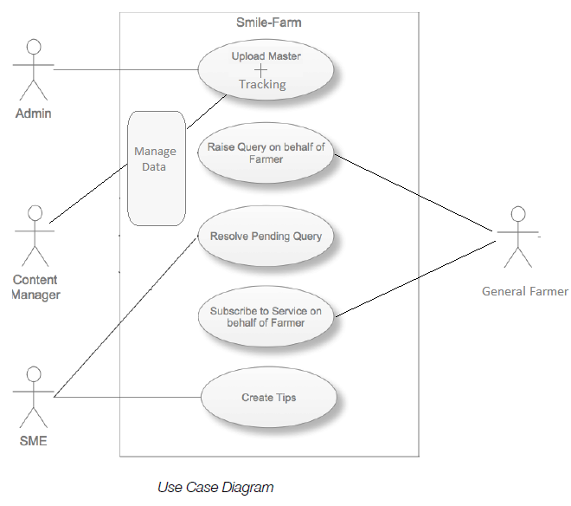Smile-Farm will give a protected client id/watchword based secured login component to get to its administrations. Once user logs in, s/he can view the dashboard of farmer queries with status, Latest Tips and Advisories added by SMEs are displayed. The implementation methodology can be well understood by the following Use-Case Diagram of ‘Smile-Farm’:

Fig. 2: UCD

**Test Cases:**

|  |  |  |  |  |
| --- | --- | --- | --- | --- |
| **Test Case ID** | **Test Title** | **Test Case Description** | **Pre-condition, if any** | **Expected Results** |
| TC001 | Login | Only the authorized users (farmer/admin/SME/content manager) can sign into the Smile-Farm. | None | Successful Login of authorized user only. |
| TC002 | Data visibility | Testing the extent of data visible to each user (farmer/admin/SME/content manager). | None | Successful Data visibility to each respective user. |
| TC003 | Chatter Tab | Checking the “Chatter tab” to ensure a bi-directional communication between users. | None | Successful  Bidirectional communication established between users. |
| TC004 | Signup  Procedure | Checking the Sign-up procedure to ensure data entry into the database. | None | Users signed up successfully. |
| TC005 | Email Service | Testing the delivery of E-Mail when a new farmer account is created. | None | Successful Email  Delivery to users. |
| TC006 | SMS Service | Testing the delivery of ‘welcome SMS’ when a new farmer signs up on the system. | None | Successful Delivery of SMS to the farmer’s phone number. |

# Technologies to be used

## Software Platform

1. **Front-end: Salesforce.com**
2. **Back-end: Salesforce.com Cloud Database**

## Hardware Platform

**HARDWARE CONFIGURATIONS:**

PROCESSOR: Intel Pentium 4 or proportional.

RAM: 2GB

Hard Disk: 800 MB of Free Disk Space.

OS: Microsoft Windows XP/7/8/10.

Browser: Chrome (Recommended), Microsoft Edge, Mozilla Firefox etc.

## Tools:

The tool that is used in SMILE FARM is as follows:

1. **Tool Name:** ApexDataLoader

**Vendor Name:**Salesforce

**Version Number: 19.00.2**

The Salesforce Data Loader / Apex Data Loader is a customer utility for the bulk import or export of statistics. The Apex Data Loader is a java-primarily based application which could bulk process the insert, update and delete on all item facts into and construct queries to extract statistics out of salesforce.Com the use of the Apex Web Services (SOAP) API.

# Advantages of this Project

The main advantages of ‘Smile-Farm’ are as follows:

* Raising ‘Awareness’.
* Availability and source of latest information in agriculture.
* Source of “Valuable Tips” to improve productivity and well-being.
* An interactive community for farmers to address their issues and problems.
* Farmers can register themselves conveniently to get regular updates.
* Provides SMS and E-Mail support to the users.
* Providing portability of the whole community to be accessed from anywhere in the world.

# Assumptions

None.

# Future Scope and further enhancement of the Smile Farm

The operability of ‘Smile-Farm’ can further be expanded to a wide scale by using the paid cloud databases and services to increase its current functional capacity.

# Smile Farm Repository Location

| **S#** | **Smile Farm Artifacts (softcopy)** | **Location** | **Verified by Project Guide** | **Verified by Lab In-Charge** |
| --- | --- | --- | --- | --- |
|  | Smile Farm Synopsis Report (Final Version) | Lab-3210, PC55,  Desktop:/Smile Farm |  |  |
|  | Smile Farm Progress updates | Lab-3210, PC55,  Desktop:/Smile Farm |  |  |
|  | Smile Farm Requirement specifications | Lab-3210, PC55,  Desktop:/Smile Farm |  |  |
|  | Smile Farm Report (Final Version) | Lab-3210, PC55,  Desktop:/Smile Farm |  |  |
|  | Test Repository | Lab-3210, PC55,  Desktop:/Smile Farm |  |  |
|  | Any other document, give details | Lab-3210, PC55,  Desktop:/Smile Farm(Company SRS) |  |  |

# Definitions, Acronyms, and Abbreviations

|  |  |
| --- | --- |
| **Abbreviation** | **Description** |
| SME | Subject Matter Expert |

# Conclusion

Every system rides drawback with it. It is seen that technology gives much better advantages in 90% cases, but we can reduce gap of these drawbacks by implementing better platform for farmers and teaching them for solution to these drawbacks to make a better world.

# References

|  |  |  |  |  |
| --- | --- | --- | --- | --- |
| **S#** | **Reference Details** | **Owner** | **Version** | **Date** |
|  | https://www.youtube.com/watch?v=xbtbo5sp9n8 | 360SMS |  |  |
|  | https://help.salesforce.com/ | Salesforce |  |  |
|  | <https://trailhead.salesforce.com/en> | Trailhead, Salesforce |  |  |

**Appendix A**

**Data Flow Diagram (DFD)**

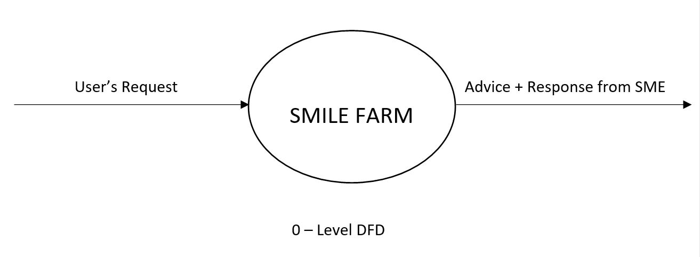

To User

Fig. 3: 0-Level DFD

**Appendix B**

**Entity-Relationship Diagram (ERD)**

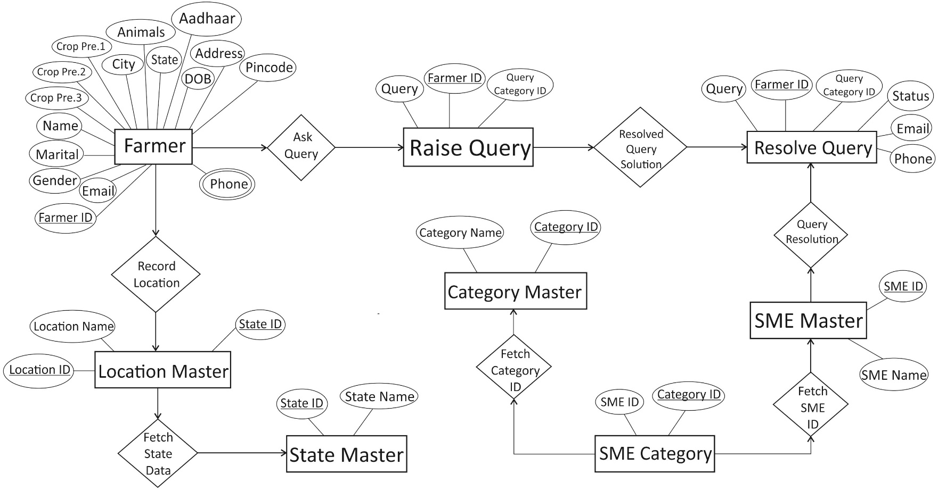

Fig. 4: ERD

**Appendix C**

**Use-Case Diagram (UCD)**



Fig. 5: UCD

**Appendix D**

**Data Dictionary (DD)**

**State Master Table:**

|  |  |  |
| --- | --- | --- |
| **Fields** | **Data type** | **Description** |
| State ID | NUMBER | It shows State ID |
| State Name | TEXT | It shows State Name |

**Location Master Table:**

|  |  |  |
| --- | --- | --- |
| **Fields** | **Data type** | **Description** |
| Location ID | NUMBER | It shows Location ID |
| Location Name | TEXT | It shows Location Name |
| State ID | NUMBER | It shows State ID |

**Category Master Table:**

|  |  |  |
| --- | --- | --- |
| **Fields** | **Data type** | **Description** |
| Category ID | NUMBER | It shows Category ID |
| Category Name | TEXT | It shows Category Name |

**SME Master Table:**

|  |  |  |
| --- | --- | --- |
| **Fields** | **Data type** | **Description** |
| SME ID | NUMBER | It shows SME ID |
| SME Name | TEXT | It shows SME Name |

**SME Category Table:**

|  |  |  |
| --- | --- | --- |
| **Fields** | **Data type** | **Description** |
| SME ID | NUMBER | It shows SME ID |
| Category ID | NUMBER | It shows Category ID |

**Raise Query Table:**

|  |  |  |
| --- | --- | --- |
| **Fields** | **Data type** | **Description** |
| Farmer ID | NUMBER | It shows Farmer ID |
| Query Category ID | NUMBER | It shows Query Category ID |
| Query | TEXT | It shows Query |

**Resolve Queries /Pending Queries Table:**

|  |  |  |
| --- | --- | --- |
| **Fields** | **Data type** | **Description** |
| Farmer ID | NUMBER | It shows Farmer |
| Phone Number | NUMBER | It shows Phone Number |
| Status | TEXT | It shows Status |
| Email | TEXT | It shows Email |
| Query ID | NUMBER | It shows Query ID |
| Query | TEXT | It shows Query |
| Solution | TEXT | It shows Solution |

**Farmer Detail Table:**

|  |  |  |
| --- | --- | --- |
| **Fields** | **Data type** | **Description** |
| Name | TEXT | It shows Name |
| Date of Birth | NUMBER | It shows Date of Birth |
| Gender | TEXT | It shows Gender |
| Marital Status | TEXT | It shows Marital Status |
| Phone | NUMBER | It shows Phone |
| Email | TEXT | It shows Email |
| Aadhaar Card | NUMBER | It shows Aadhaar Card |
| Address | TEXT | It shows Address |
| City | TEXT | It shows City |
| Pin code | NUMBER | It shows Pin code |
| States | TEXT | It shows States |
| Animals | TEXT | It shows Animals |
| Crop Preference 1 | TEXT | It shows Crop Preference 1 |
| Crop Preference 2 | TEXT | It shows Crop Preference 2 |
| Crop Preference 3 | TEXT | It shows Crop Preference 3 |

**Appendix E**

**Screen Shots**

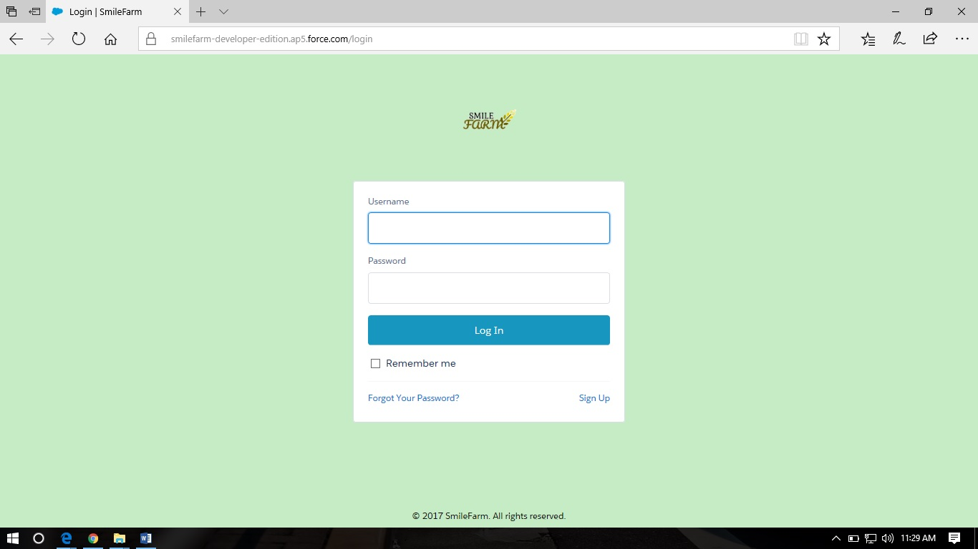**Login Page:**

**Farmer Detail Page by Admin:**

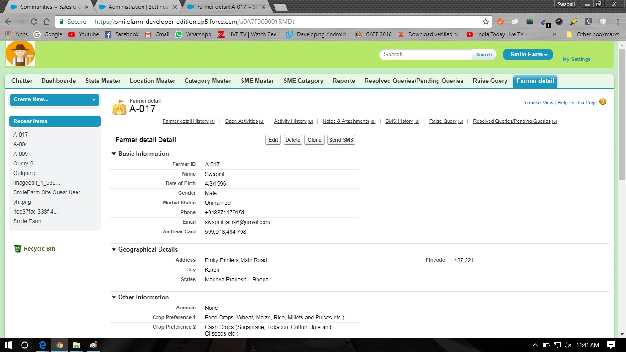

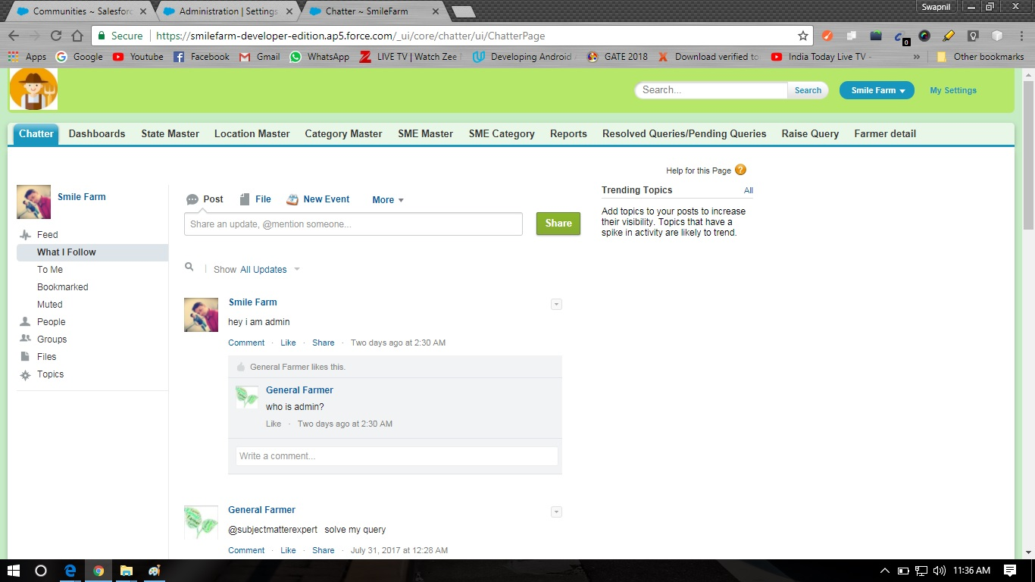**Admin Chatter Page:**

**Content Manager Chatter Page:**

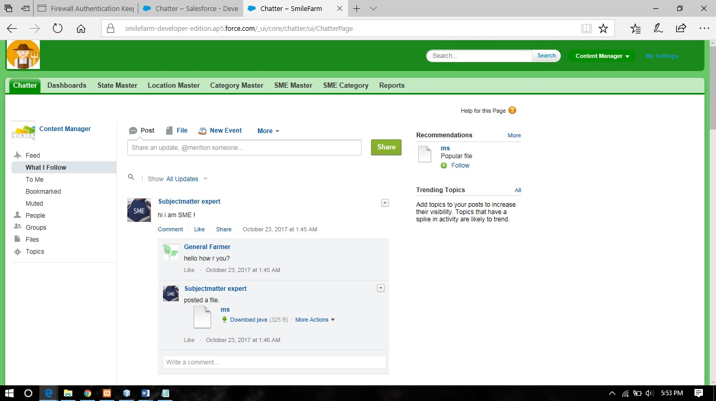

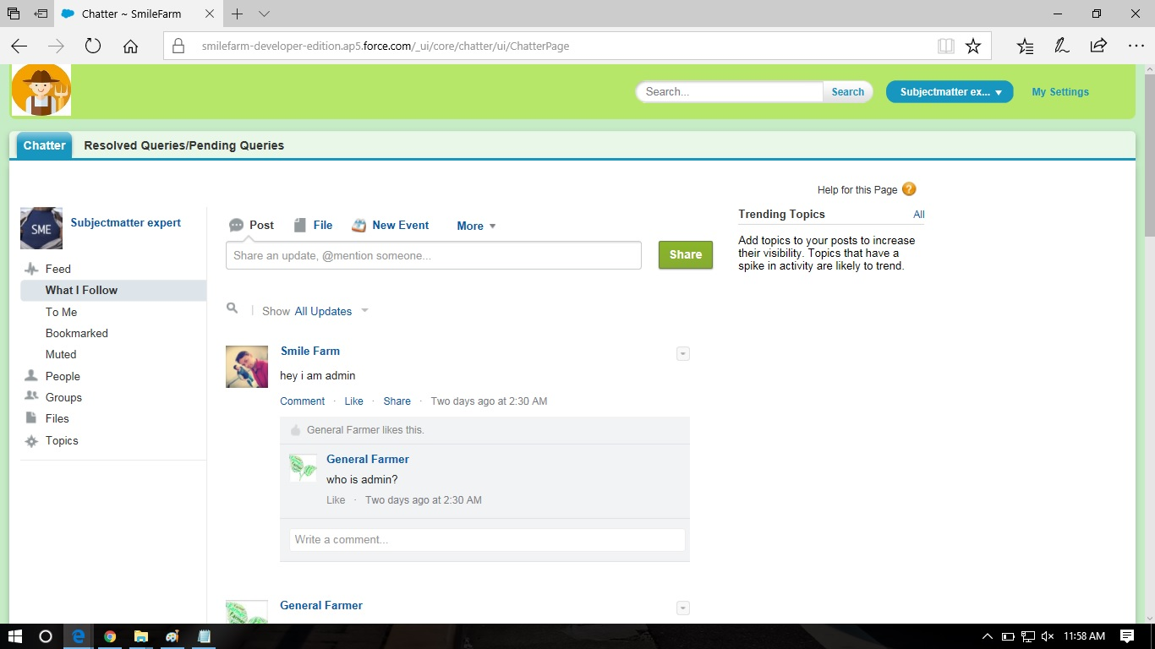**Subject Matter Expert(SME) Chatter Page:**

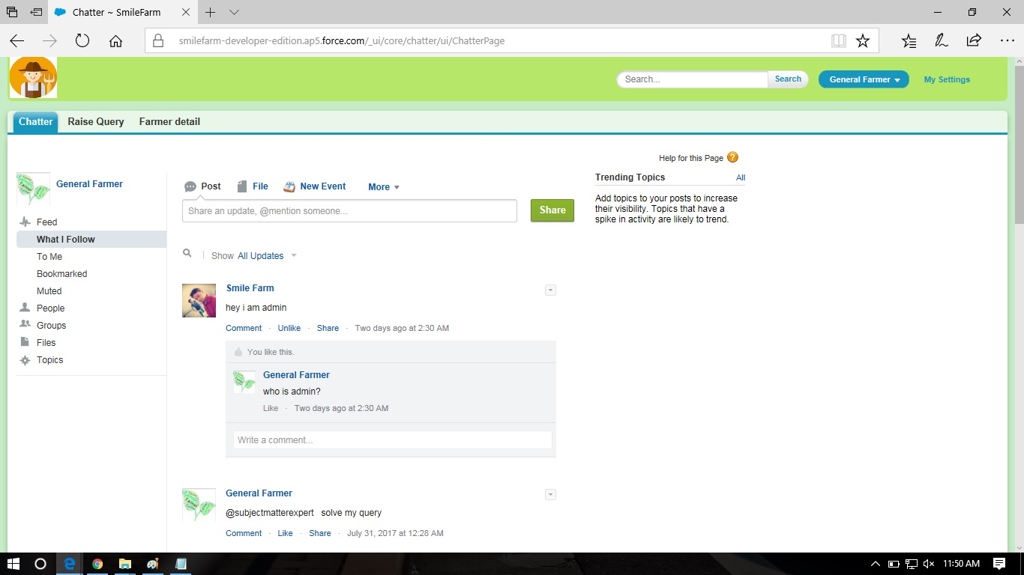**General Farmer Chatter Page:**

**Apex Data Laoder :**

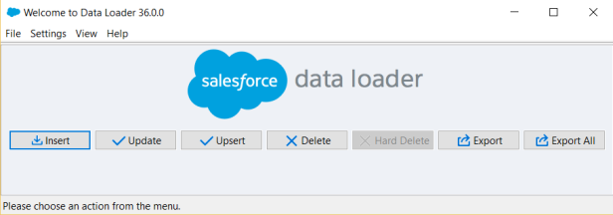

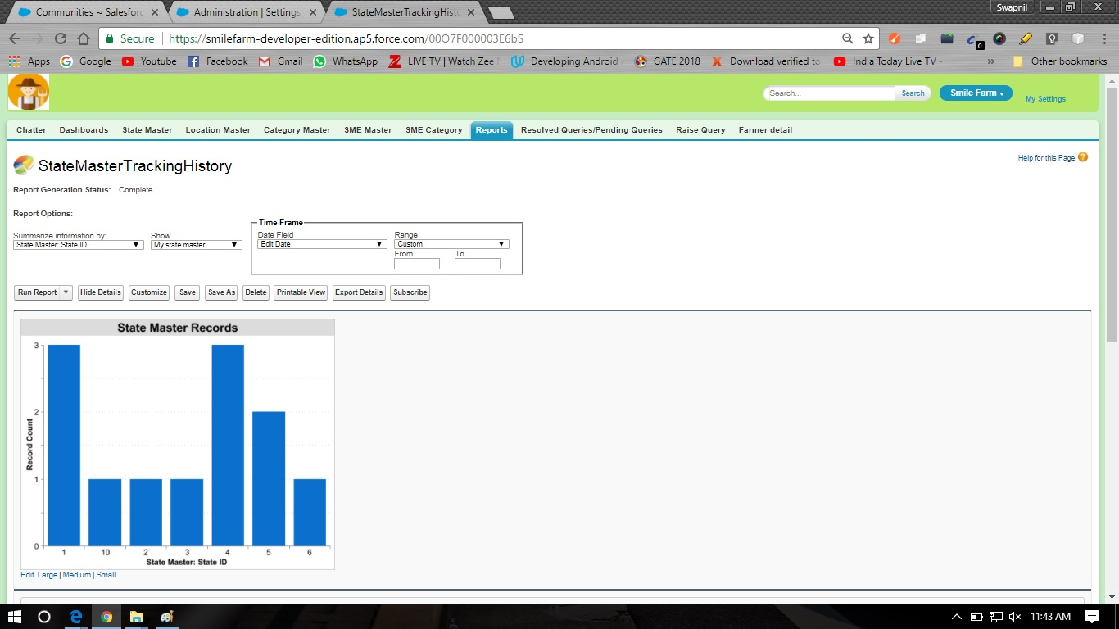**Admin Report Dashboard Page: 1**

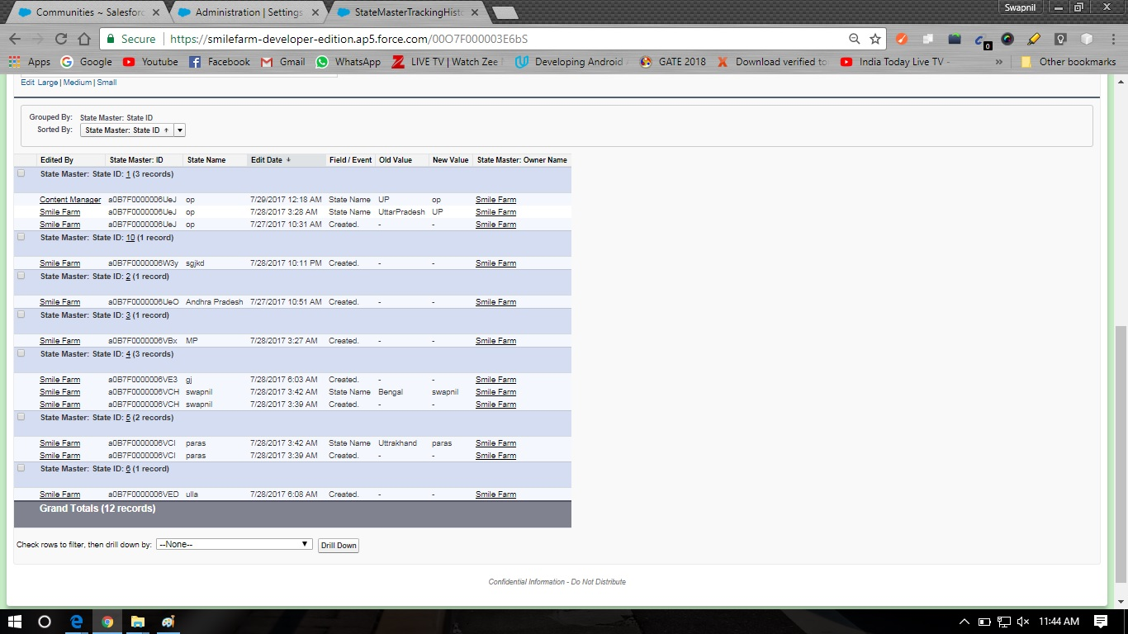**Admin Report Dashboard Page: 2**

**Farmer Form Page:**

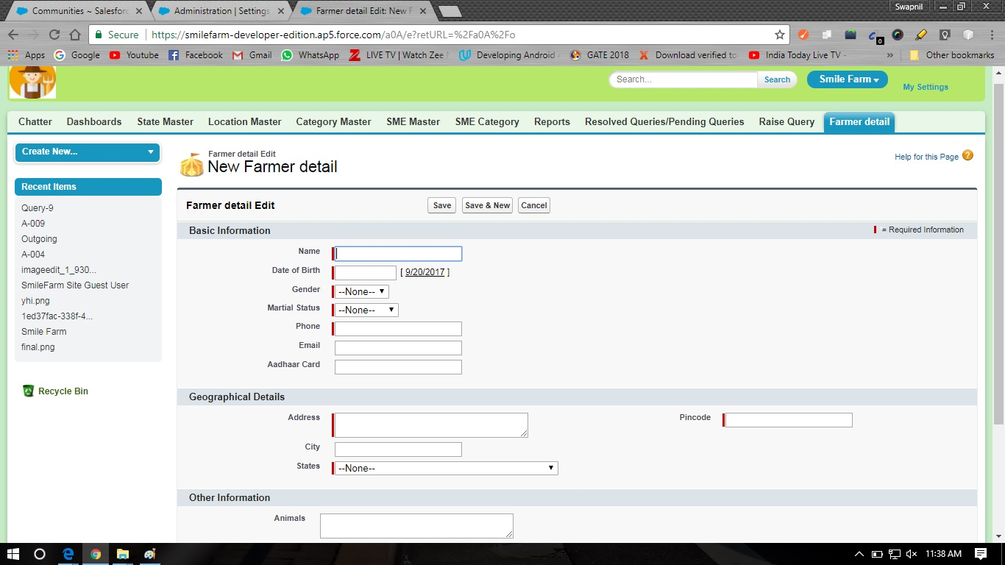

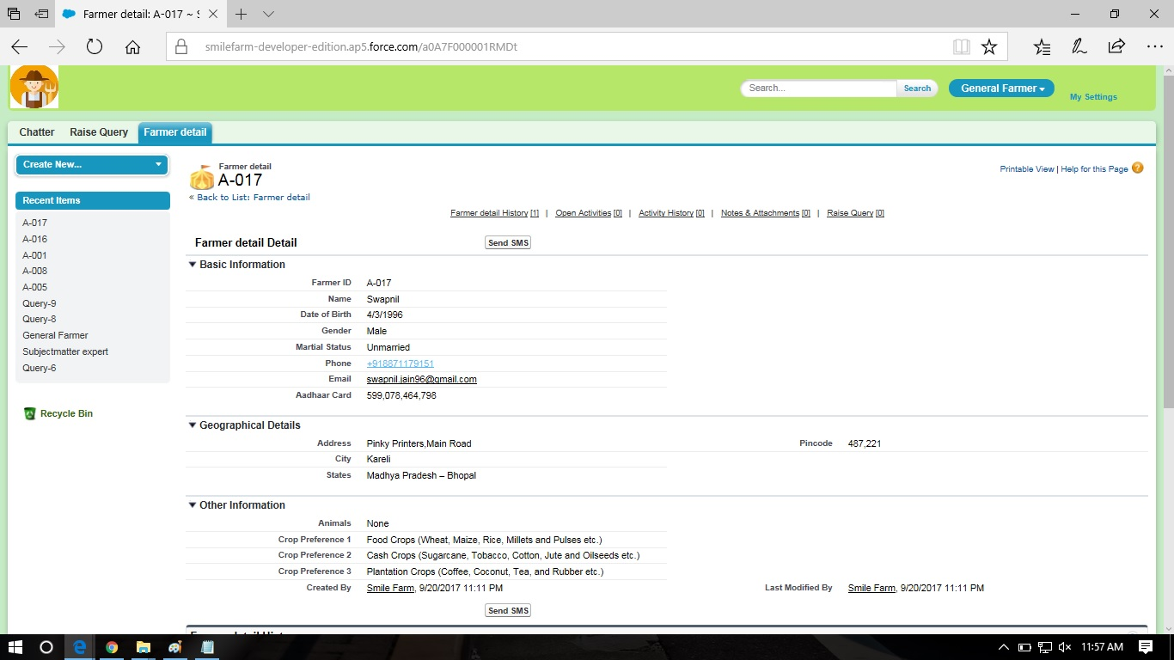**Farmer Detail Page:**

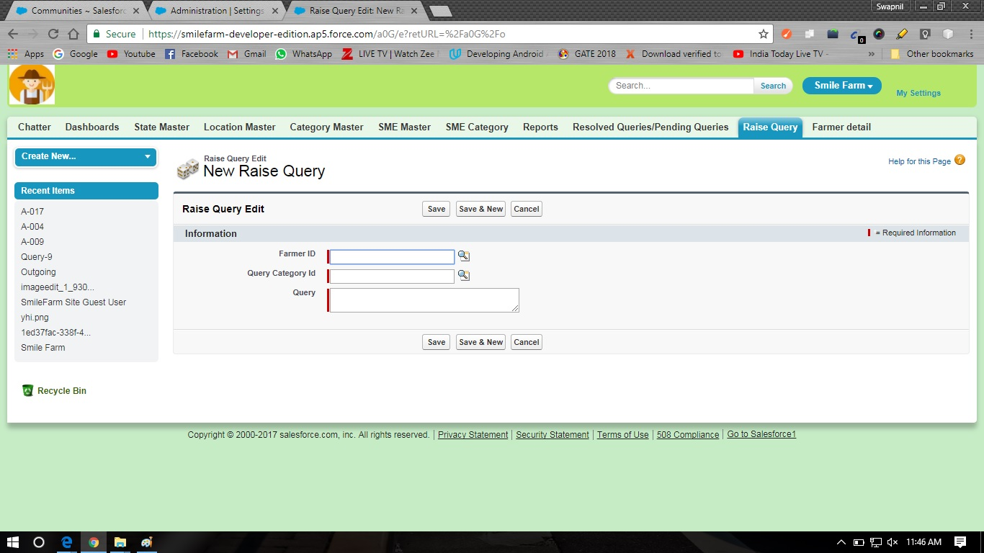**Raise Query Page:**

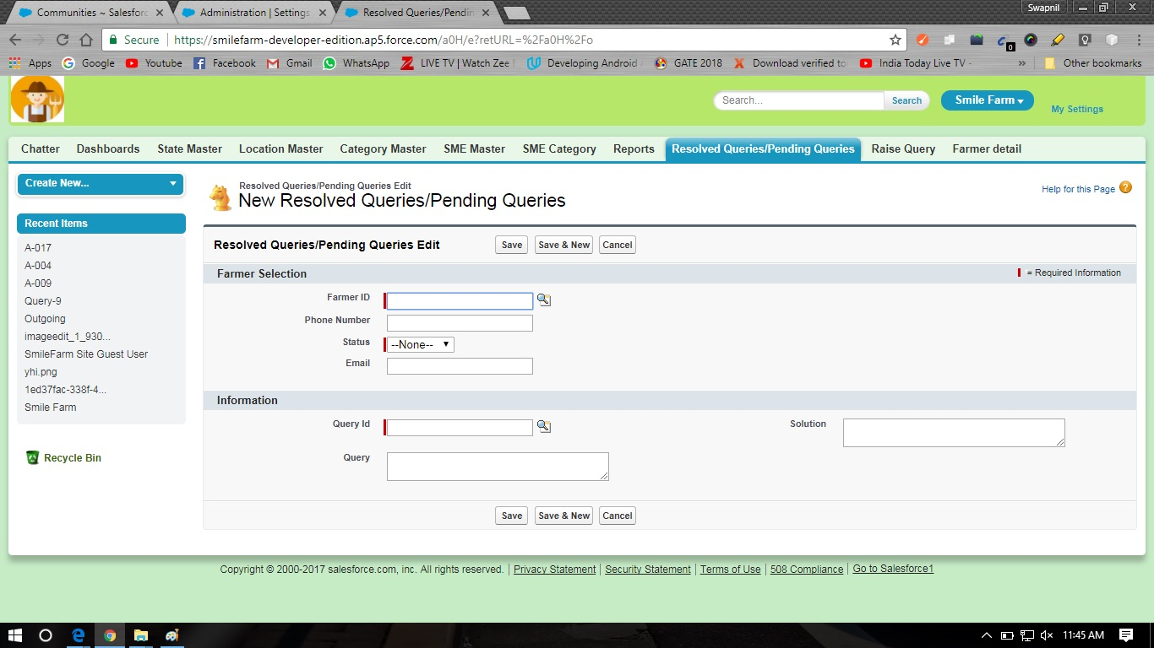**Resolve Query/Pending Query Page:**

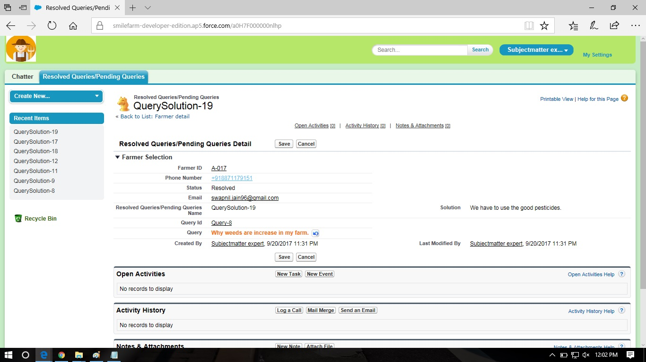**QuerySolution Page:**

**Admin ReportTab Page:**

